Heart-healthy activities assignment
Students’ Name
Institutional Affiliation

Heart-healthy activities
Boiled lentils
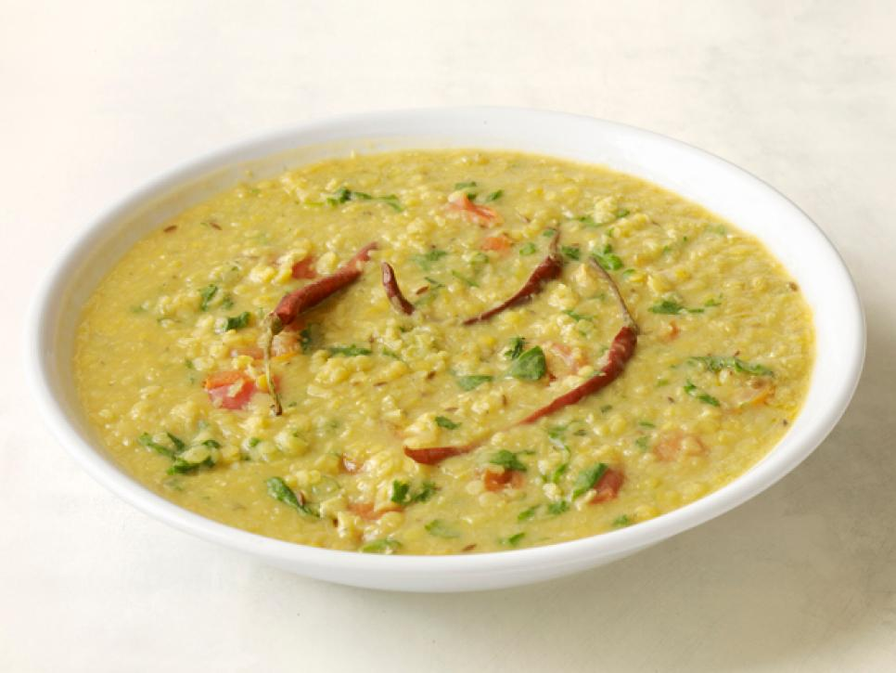
Source: Food Network (2018)
According to Food Network (2018), this bowl of steamed lentils is heart healthy. It can be part of lunch or dinner or even be paired with a favorite salad. According to Ware (2018), lentils contain high protein and fiber that are all healthy to the heart. This food is good to my health because the fiber, folic acid, and potassium are heart healthy. More fiber reduces the bad cholesterols or LDLs. Moreover, lentils are cheaper and very easy to prepare.

Fried chicken
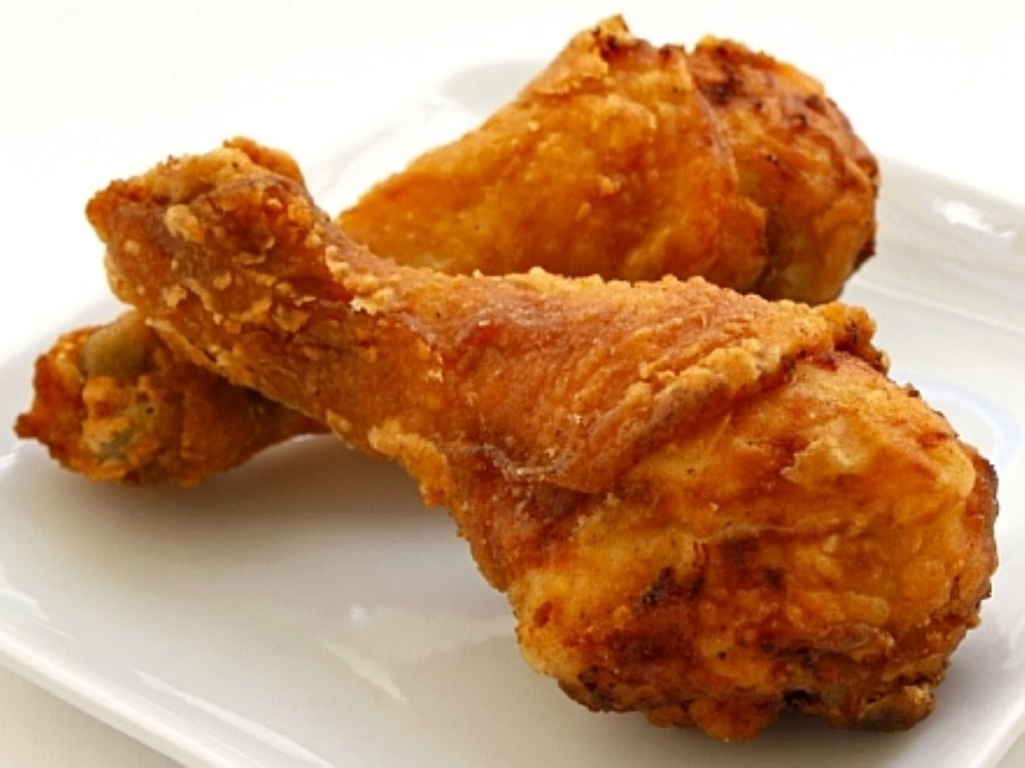
Source: Macmillan (2017)
According to Macmillan (2017), high consumption of fried foods such as fried chicken increases the risk of heart disease. Partly, this is due to the normal methods of frying that creates certain types of fats called Trans fats. The Trans fats are known to raise the level of bad cholesterol and at the same time lower the level of good type. The rise in the level of bad cholesterol increases the risk of heart disease.
According to WebMed (2017), other than avoiding eating foods that increase bad cholesterols and lowers good cholesterols, one may also exercise. This week, I decided to walk from work to home which was just a few kilometers away. By walking or running, I breathe harder and my heart pumps faster. This way, the heart too remains healthy.

References
Food Network. (2018). Heart-healthy recipes. Retrieved from https://www.foodnetwork.com/healthy/photos/favorite-heart-healthy-recipes.
Macmillan, A. (2018). The 10 worst foods for your heart. Retrieved from http://time.com/4669635/worst-foods-for-heart/.
Ware, M. (2018). Everything you need to know about lentils. Retrieved from https://www.medicalnewstoday.com/articles/297638.php.
Web Med. (2017). Exercise for a Healthy Heart. Retrieved from https://www.webmd.com/fitness-exercise/guide/exercise-healthy-heart#1

